**COURSEWORK – E-COMMERCE SITE**

**By: Ming Yao**

Contents

Analysis 4

Project Introduction 4

Identifying Problem 4

Project Definition 4

Justification of how the problem can be solved by computational methods 5

Thinking Abstractly 5

Thinking Ahead 5

Thinking Procedurally 6

Thinking Concurrently 6

Thinking Logically 7

Stakeholders 8

Internal Stakeholders 8

External Stakeholder 8

Summary of interviews 10

Problem Research and Similar Competitors 11

Similar Solution 1) Amazon 11

Similar Solution 2) Etsy 13

Similar solution 3) John Lewis 15

Conclusion from similar products 17

Solution proposal 17

Features of Solution 17

Limitations of Solution 17

Computational thinking 18

Success Criteria 19

OCR success criteria 19

My Success Criteria 19

# Analysis

This section will entail the analysis of the problem at hand, describing the process of my solution, and finding what features are requires or wanted by the stakeholders, as well as satisfying what they expect from this solution

## Project Introduction

### Identifying Problem

Previously, my sister and mother had made home-made products, such as crochet animals, knitting and homemade soft toys, who then distributed it to family, relatives and family friends. After becoming more of a hobby, they decided to start selling to people nearby, starting with our neighbourhood. Having seen them spend their time producing these products, and helping transport and deliver these items, I have observed that the process of physically spreading awareness and having a system to log who has bought which item became hard and confusing. The ordering system for these homemade products was inefficient and not worked on.

### Project Definition

For my project, I am planning to make a family-friendly ordering system for homemade products made by family members ; an ordering system similar to Lazada, amazon, or shopee, where you can view products and buy them. I plan to create a user interface which lets them view products through a filter (category based: types of product, price range, alphabetically), and add them to a specific cart. Additionally, users will be able to make an account and log in and log out so that their data is saved (address, contact details, etc)

Some pictures of the product that will be used:

## Justification of how the problem can be solved by computational methods

### Thinking Abstractly

Being web-based provides a solution of the customers that want a specialised, home-made crochet as it solves the problem of physically calling up my mother or sister in order to place an order. This website creates a process where users are able to search, sort and filter through the items available, and finally read through the details about a specific item (price, name, materials, etc) before purchasing and placing an order on their desired product. On the main page of the website, only key details will be displayed so that customers are able to view a wide variety of items at once, and will be able to read into depth of interested items.

On the admin side of this project, I create a solution for my mother and sister so that they wont need to receive countless phone calls and messages. This website will have an admin platform so that only admins are allowed to view orders that has been places as well as view any reviews made by previous customers.

### Thinking Ahead

Inputs:

I will need customer details (Full name, Address for delivery, email address, phone number, payment details such as a credit card, and a password for the account). These details will be used for the registration of an account and be used for the deliver and payment process. I will also need an input from the admins for new items being sold (a description of the item and its name, and multiple pictures of that item)

Output:

The outputs of my website will include the total cost of the items that the user has added to cart and wants to purchase, and a digital receipt which allows them to view the order that they have made (sent to email as well as on the screen that they were shopping on)

Caching:

Caching could be used in several components of my website such as the items produced as well as the CSS of my website which details the appearance of the website. It is because I will be unable to frequently update these components, so that caching them can be beneficial in terms of reducing time taken to load up the webpage

Other Details:

I will most likely reuse components of the website across all webpages, such as a general CSS style sheet so that multiple pages of the website have the same style (product page and main page). This helps each page of my website follow the same or similar colour scheme and architecture to maintain a sense of corporate image.

### Thinking Procedurally

To simplify the task that will need to be achieved, I am able to decompose specific problems into smaller steps to handle. For example:

Adding to basket:

* The customer should be able to press add to cart from a product page
  + If customer wishes to read details of a product, there should be another button to add to cart there
* Customer should be able to then go back to the online menu of products
* The customer should then be able to click on the shopping cart icon to view all their products in cart

Placing an order:

* Customer should be able to view all orders in their basket
  + If customer wishes to buy a single item, they should be allowed to press buy item from the products page itself
* Customer should be able to then login
* Customer must enter their full passcode and match the passcode stored in the system
* Customer should then be able to press a checkout button which leads them into the payment system they wish to use

### Thinking Concurrently

Specific aspects of my website will need to be able to be performed simultaneously on multiple different users interface, and these multiple interfaces shouldn’t be slowed or hindered by one another

* Allows multiple customers to order and buy a product at the same time
* Allows the admin page / supervision monitor to be updates immediately as soon as an order has been placed
* Allows admin page to view who is currently signed in or when a new account has been made

### Thinking Logically

Branching and pipelining will be needed for certain aspects of my solution, and to allow the website to function fast. For example, if a customer has finished viewing items they should be brought to a checkout page. If they haven’t finished, they should be looped back into viewing items.



## Stakeholders

There are three main stakeholders for my website that I will need to consider: my mother, sister, and the general public. Two of which are the origins of the website, and I will use a few friends who is a regular e-commerce as an example of the general public. I will conduct interviews for each of them in order to get feedback on how to shape my website in order for it to be desired by other customers.

### Internal Stakeholders

For my internal stakeholders (the ones who are involved in the creation of my website), I asked them general questions regarding the features and desires for the website. I will need to have a full grasp of the idea of website they would like to be built before starting the process. I am hoping for them to be able to add items on their own without my help.

Main management will be my mom, with my sister helping on holidays. She would like an easy accessible and functional website in order to add items easily and be able to view who has bought which item. I will need to consider efficiency as my mother may be really busy and may be time consuming to switch between tabs

General questions:

* Would you like to constantly add new items to the website weekly or monthly?
* What crowd of customers are you hoping to look for?
* How do you wish for the website to differ from current ongoing websites, such as amazon or Lazada?
* Have you previously missed orders by other people (forgot to produce a specific product for someone else)?
* Which webpage needs the most attention?
  + Assuming it’s the homepage, what information and detail would you like to add to the homepage?
* Have you had any negative experiences with selling your product?
  + Can this website help solve that problem?
* What would you like customers to be able to do?
  + Will there be promotions and pop up adds?
* What functionalities will management need?

#### My mother:

#### My sister:

### External Stakeholder

For my external stakeholders (the public), I asked for the drawbacks and downsides of currently running e-commerce sites, as well as what they look for when they shop for products (what makes an e-commerce site easy and accessible). Users should be able to comfortably browse the website, and create their own personal account where they can store information. I will also ask my aunty who is a frequent user of shopping online, and someone who helps represent other brands by spreading their awareness on social media.

General questions:

* What do you look for in a website that sells home-made products?
  + Do aesthetics of a website affect your experience
* What problems do you face with current websites/applications that allow you to shop for products?
* How can an e-commerce website meet your needs to shop for home-made products, such as knitting and crochet?
* Are there any specific features that will prompt you to use a certain brand over another?

#### My friend (angel):

* A website that is easy to navigate, I like a minimalist design, so colours are not really clashing with each other, product details, don’t make the font too small and not too much texts (more pictures)
* If I don’t sign up/login in the webpage, they make me login after adding to the cart, then when I login I lose all the items in my cart.
  + It is hard to search for products that I want (names are very complicated)
  + Not enough categories to pick from for items that I desire
* A website that shows pictures of the product and of the different colours. Including the sizing too (cm/m) as pictures may be very deceiving.
* Websites with no ads, I don’t like websites that when they put suggested items after adding something to cart, it just checks the suggested item and I have to untick it

#### My friend (Grace):

* A website that is very sleek and minimalistic so that it is easier on the user’s eyes and makes it look very professional and it helps to make the information you want to get across clearer to the user’s shopping for the product
* When you put a specific item in search bar, a lot of results come out which makes it hard to search for a specific item that I design
* A website that shows a variety of categories so that you can find the product you want without having to search for the names
* When a website has a wish list (a section where you can favourite and save the items you like without having to add it to a specific basket / cart)

#### My aunty (Jessie):

* A website with very clean pictures (with a clear price / less text about it)
  + There will be text when you click on the picture such as a description
  + Product detail only when I have clicked on the product itself so that the homepage is very minimalistic and easy to read
  + A website that is easy to navigate in order to please
  + For homemade products, a video could be helpful
* I hate it when I have to sign up in order to checkout
  + If I just want to checkout without putting personal details, I want to be able to checkout straight towards the payment gateway so that it is easy to buy products
  + I would like it if I can sign in as a member for any discounted items and promotions that add up in my account, however if it is just to buy a simple item I would prefer if I can just proceed to checkout where I have to insert my bank details
* I don’t like when a website has too many steps
  + When I have to continuously click numerous buttons to checkout and it gets too clicky
  + You need a website to look slick and very easy to checkout
    - Big buttons for adding to cart
    - Price on every picture
* I would choose a certain website over another if it is very fast and easy to access
  + When a website has minimal buttons but the key details are shown clearly
    - Details such as delivery date, etc

### Summary of interviews

Features that will be added:

* Homepage
  + Eye catching colours which is not too bright and dark
    - Must be aesthetically pleasing in order to convince users to use this website
  + Loads of pictures with minimal detail possible
    - Picture + price + name
  + Certain videos or sliding pictures of the production itself so that it is very persuasive
  + Very little buttons
    - Only navigation bar, and certain promotion buttons
* Other sections of the website
  + Make the shopping cart page very minimalistic and only asks you to sign in when necessary, if not it will just ask for a payment page + address page
  + Very little description on product page until you click in on the specific product itself

Features to exclude:

* Don’t make the website have too many buttons
* Make sure you don’t jumble up the search bar
* Make sure the login/sign up page is completely separate to the shopping cart page and it doesn’t affect one another.

## Problem Research and Similar Competitors

The main problem of this website is the similarities between websites already running. Furthermore, the website will need a system where management can easily view all the data from the person who has bought a product all at once (address, name, product and custom features)

### Similar Solution 1) Amazon







Features identified –

* Homepage which shows you the latest deals, promotions, trending and most popular items
* Top navigation bar which does not change when moving between web pages
* Categories stored on top bar as well as side bar
* Sign up/Log in page
  + Connected to the shopping where you have to login whenever you wish to checkout
* A lot of images in order to show the pictures of the product itself as well as its name + discount

Drawbacks of Amazon –

* looks very messy and complicated
* a lot of different types of products linked to amazon, so there is a lot of categories that may get confusing
* ****may be hard to know where to start

### Similar Solution 2) Etsy

Etsy by far is my favourite website so far, as it has minimalistic designs and very eye catching colours, which I will need to implement in my designs



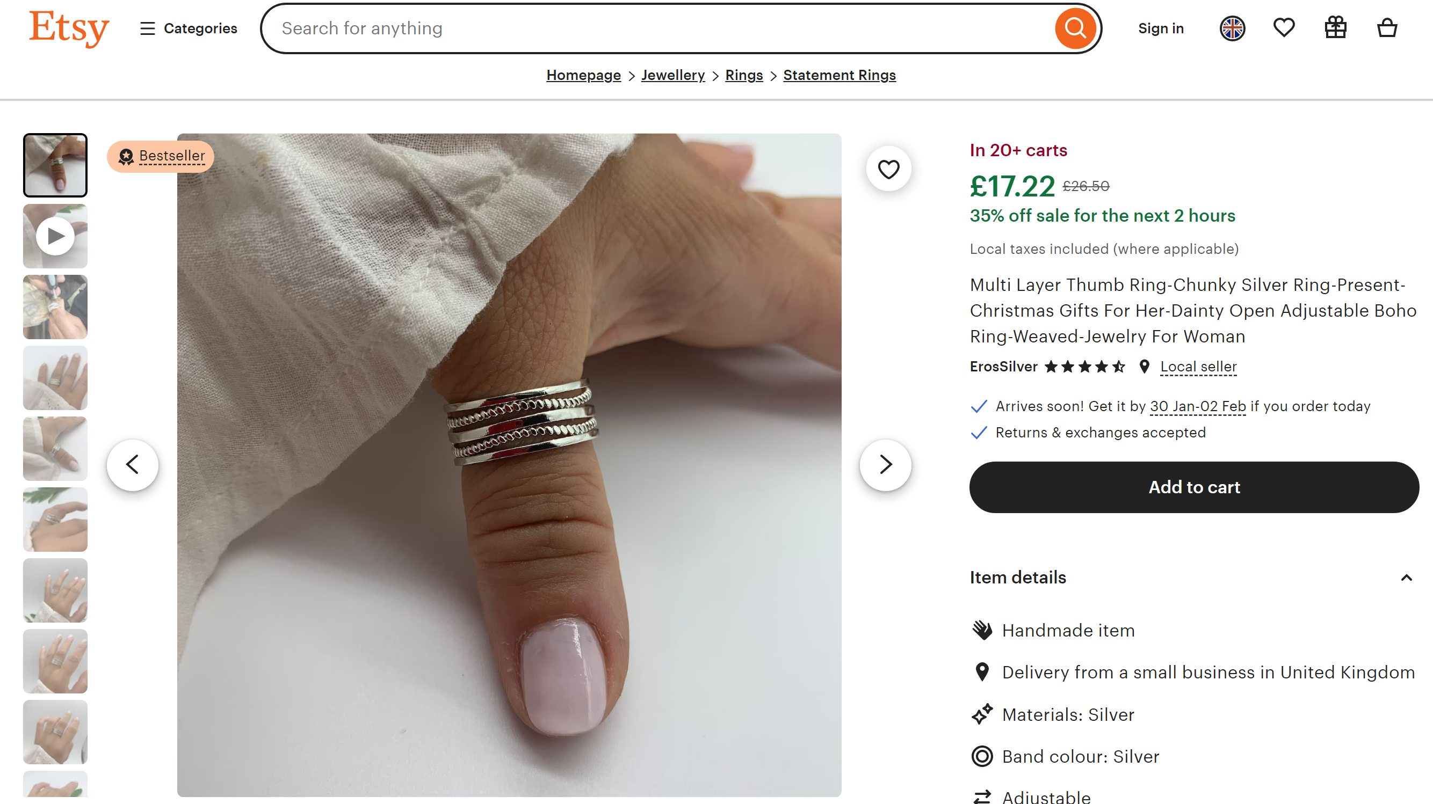



Features identified–

* minimalist homepage with very little buttons for categories and product ideas
* top navigation bar which doesn’t change
  + very minimalist as there’s not too much detail but all the important information is displayed
* sign in/ log in page
* able to clearly change language of the website
* when in a specific category, your able to easily change category without having to go back to homepage

Drawbacks of Etsy –

* doesn’t make you sign in or log in before viewing shopping cart



Etsy offers this small description on what they are which shows how they work

### Similar solution 3) John Lewis







Features identified –

* Homepage which shows you the latest deals, promotions, trending and most popular items
* Top navigation bar which does not change when moving between web pages
* Categories stored on top navigation bar so it is easy to find
* Sign up/Log in page
  + Connected to the shopping where you have to login whenever you wish to checkout
* A lot of images in order to show the pictures of the product itself as well as its name + discount
* Shows deals up to a specific discount so your able to easily see how much discounts a specific item have

Drawbacks of John Lewis –

* Very messy navigation bar so it may be confusing on where to search for specific products
* ****Looks confusing and unsure of where to start to search for specific products

### Conclusion from similar products

These here websites serves its purpose to publish products and purchase them in a time efficient manner, however I feel like for majority of these websites, a significant improvement could be the aesthetics of the website: minimalistic and eye catching. I think for john Lewis and amazon, the homepage could be more condensed so that the viewers are more likely to stay on that specific website. Additionally, I believe improvements could be made through the shopping carts page by making It less confusing with fewer problems that occur, as it was a problem throughout both my interviews and when researching these websites.

Some ideas to implement in my website:

* Minimalistic homepage with very stylistic buttons like Etsy’s homepage
* A very generalised theme across all my webpages even when it goes into the products
* A form of recommended products and items that viewers may like
* An easy and accessible login / sign up / carts page

## Solution proposal

### Features of Solution

#### Customer Features

* Customers will be able to add items to cart with or without an account and possibly be able to buy items without an account
  + Will need to just key in delivery address and name
* Customers will be able to leave reviews on the websites either for a specific product or a more general comment about the whole website and service as a whole
* Customers will be able to search for their desired items without having to search for the whole exact name
  + If they search for a batman watch, a few variety of batman watches will appear
* Customers can cancel their order after pressing checkout so that they can recheck their order before paying
* Each customer can access the website at the same time
* Customers will be able to see and easily access the wide variety of products ranging from each category
* There will be a page where you can add favourited items to a list and it will save it for whenever you re-log in

#### Admin Features

* Admins will be able to login via an admin portal with an admins account. This will bring them to a separate system where they can manage all the orders being places and find out which order is meant to be delivered to where
* Admins will be able to add new products to the menu when desired
  + They will have to key in details such as: product name, product description, product price, picture of product, etc
* Admins will be able to remove products if they no longer produce that specific product
* A weekly income will be calculated automatically and admins will be able to see how much has been made
  + They will also be allowed to add in any cost of production to find total profits after deducting the cost of production
* There will be a webpage inside admins portal where it gives an analysis of the website itself
  + This will showcase busiest times and days when people shop, most bought items, most viewed items, and the amount of time customers spend on the website#

### Limitations of Solution

Limitations of my solution due to the complexity of various sections of the website:

* The payment system may be very hard to achieve as it will ask for card details, etc and will need to be accessed via a proper bank
  + I will implement a proper system at a later stage of my website

## Computational thinking

## Success Criteria

![Programming project (Component 03 or 04) marking criteria 
AO 2.2 Analysis (maximum 10 marks) 
marks 
The candidate Will have: 
• Identified some features 
that make the problem 
solvable by computational 
methods. 
• Identified suitable 
stakeholders for the 
project and described 
them and some of their 
requirements. 
• Identified some appropriate 
features to incorporate into 
their solution. 
• Identified some features 
of the proposed 
computational solution. 
• Identified some limitations 
of the proposed solution. 
• Identified some 
requirements for the 
solution. 
• Identified some success 
criteria for the proposed 
solution. 
3—5 marks 
• Described the features that 
make the problem solvable by 
computational methods. 
• Identified suitable 
stakeholders for the project 
and described how they will 
make use of the proposed 
solution. 
• Researched the problem 
looking at existing solutions to 
similar problems identifying 
some appropriate features 
to incorporate into their 
solution. 
• Identified the essential 
features Of the proposed 
computational solution. 
• Identified and described some 
limitations of the proposed 
solution. 
• Identified most requirements 
for the solution. 
• Identified some measurable 
success criteria for the 
proposed solution. 
— 70 marks 
marks 
• Described the features that make the 
problem solvable by computational 
methods and why it is amenable to a 
computational approach. 
• Identified suitable stakeholders for the 
project and described them and how 
they will make use of the proposed 
solution and why it is appropriate to 
their needs. 
• Researched the problem in depth 
looking at existing solutions to similar 
problems identifying and describing 
suitable approaches based on this 
research. 
• Identified and described the 
essential features of the proposed 
computational solution. 
• Identified and explained any limitations 
of the proposed solution. 
• Specified the requirements for the 
solution including (as appropriate) any 
hardware and software requirements. 
• Identified measurable success criteria 
for the proposed solution. 
9—10 marks 
• Described and justified the features that make 
the problem solvable by computational methods, 
explaining why it is amenable to a computational 
approach. 
• Identified suitable stakeholders for the project 
and described them explaining how they will 
make use of the proposed solution and why it is 
appropriate to their needs. 
• Researched the problem in depth looking at 
existing solutions to similar problems, identifying 
and justifying suitable approaches based on this 
research. 
• Identified the essential features of the proposed 
computational solution explaining these choices. 
• Identified and explained with justification any 
limitations of the proposed solution. 
• Specified and justified the requirements for the 
solution including (as appropriate) any hardware 
and software requirements. 
• Identified and justified measurable success 
criteria for the proposed solution. 
O marks = no response or no response worthy of credit. ]()

### OCR success criteria

### My Success Criteria